HDOC DAY-11

1.Algorithm
Option 1: Sum of squares using while loop
1.Start.
2.Input a positive integer n.
3.Set temp = n and sum = 0.
4.Repeat while temp > 0:
5.Find digit using digit = temp % 10.
6.Add digit × digit to sum.
7.Remove last digit using temp = temp / 10.
8.Display sum.
9.Stop.
Option 2: Sum of cubes using for loop
Start.
Input a positive integer n.
Set sum = 0.
Use a for loop to process every digit.
Find each digit using % 10.
Add cube of the digit to sum.
Display sum.
Stop.
Option 3: Difference using do-while loop
Start.
Input a positive integer n.
Set temp = n, sumSquare = 0, sumCube = 0.
Use a do-while loop to process each digit.
Calculate square and cube of every digit.
Calculate difference = sumCube - sumSquare.
Display the difference.
Stop.
2. C Program
#include <stdio.h>

int main()
{
int n, choice;
int temp, digit;
int sum, sumSquare, sumCube, difference;

printf("Enter a positive integer: ");
scanf("%d", &n);

printf("\n----- MENU -----\n");
printf("1. Sum of squares of digits (while loop)\n");
printf("2. Sum of cubes of digits (for loop)\n");
printf("3. Difference between sum of cubes and sum of squares (do-while loop)\n");
printf("Enter your choice: ");
scanf("%d", &choice);

switch (choice)
{
case 1:
temp = n;
sum = 0;

while (temp > 0)
{
digit = temp % 10;
sum = sum + digit * digit;
temp = temp / 10;
}

printf("Sum of squares of digits = %d\n", sum);
break;

case 2:
sum = 0;

for (temp = n; temp > 0; temp = temp / 10)
{
digit = temp % 10;
sum = sum + digit * digit * digit;
}

printf("Sum of cubes of digits = %d\n", sum);
break;

case 3:
temp = n;
sumSquare = 0;
sumCube = 0;

do
{
digit = temp % 10;
sumSquare = sumSquare + digit * digit;
sumCube = sumCube + digit * digit * digit;
temp = temp / 10;

} while (temp > 0);

difference = sumCube - sumSquare;

printf("Sum of squares = %d\n", sumSquare);
printf("Sum of cubes = %d\n", sumCube);
printf("Difference = %d\n", difference);
break;

default:
printf("Invalid choice!\n");
}

return 0;
}
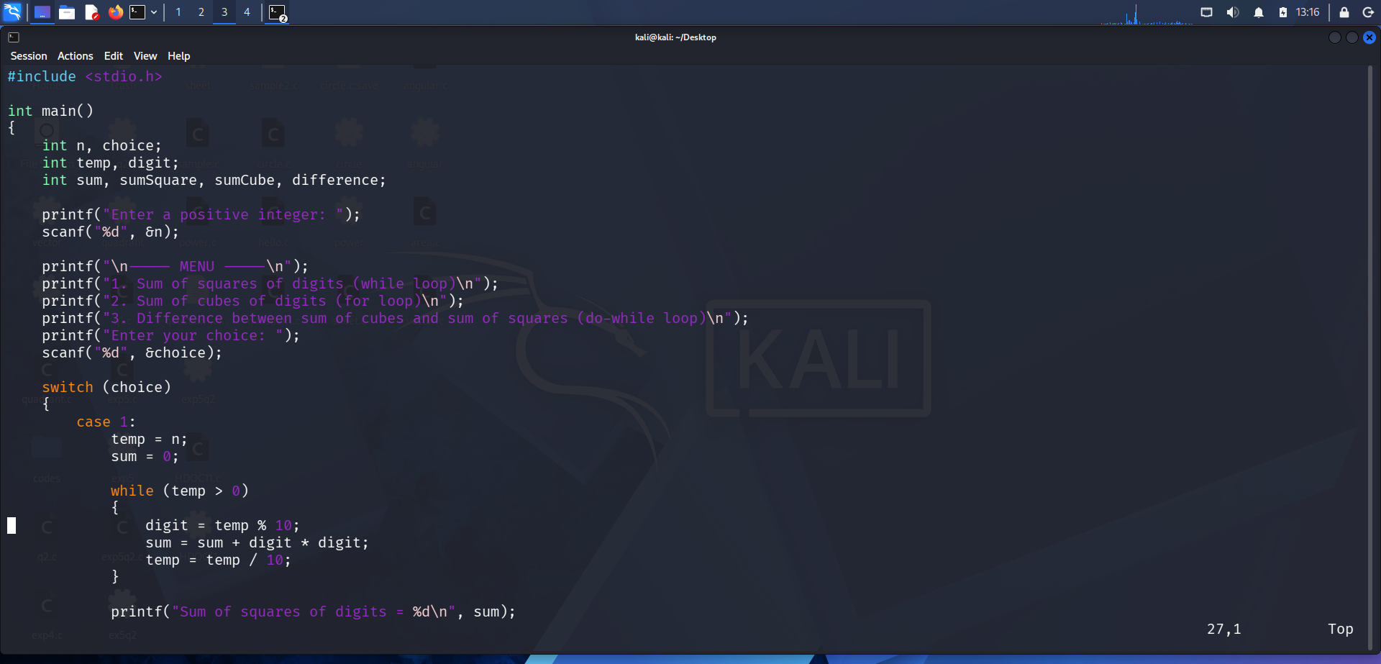
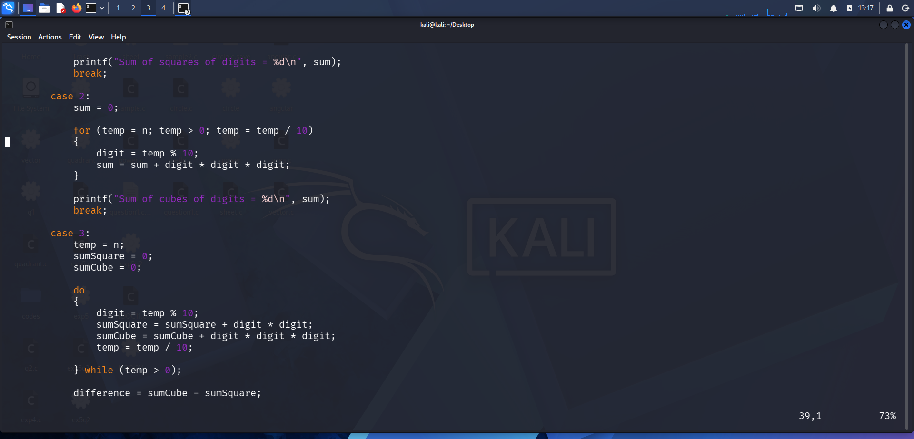
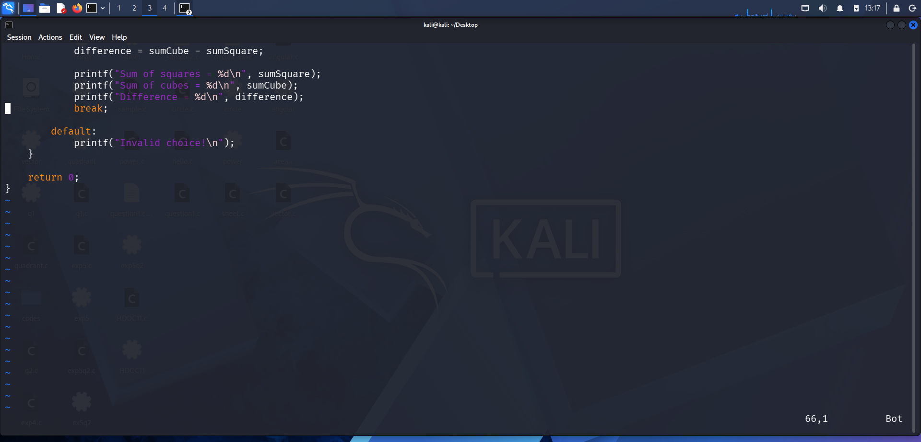
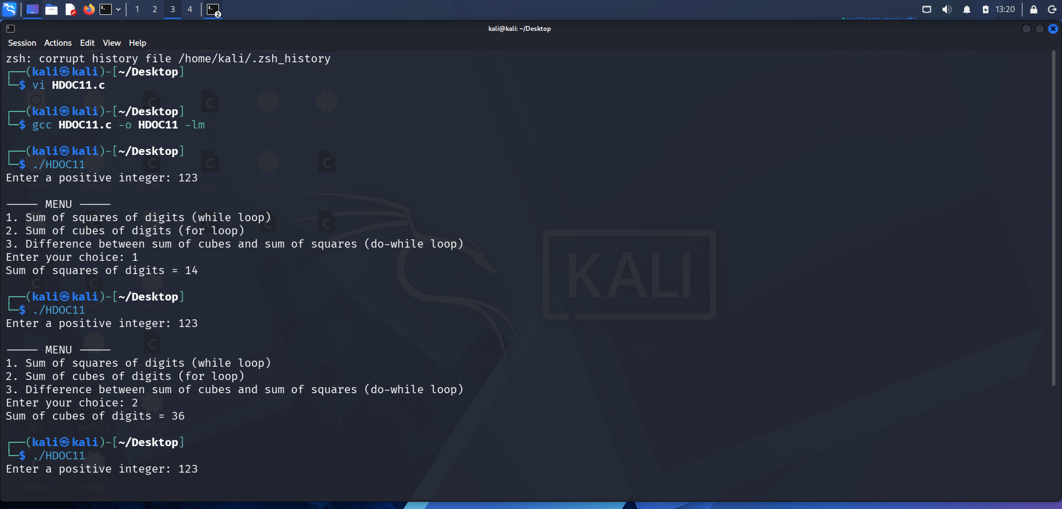
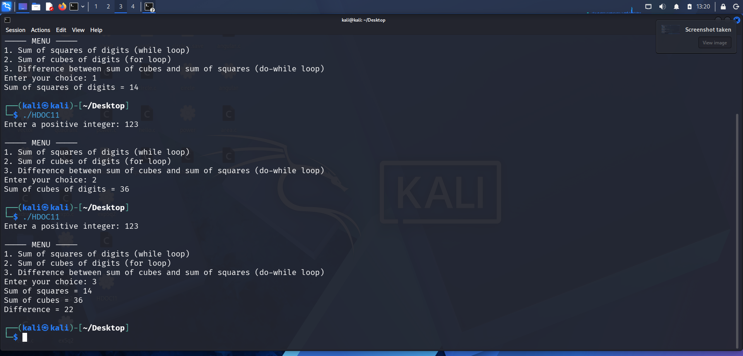

3. Test Case Table
Test case | Input number | choice | operation | Expected Output
TC1 | 123 | 1 | Sum of squares | 14
TC2 | 123 | 2 | Sum of cubes | 36
TC3 | 123 | 3 | Difference | 22

Calculation for 123:
Squares = 1² + 2² + 3² = 14
Cubes = 1³ + 2³ + 3³ = 36
Difference = 36 -14 = 22

